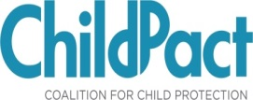

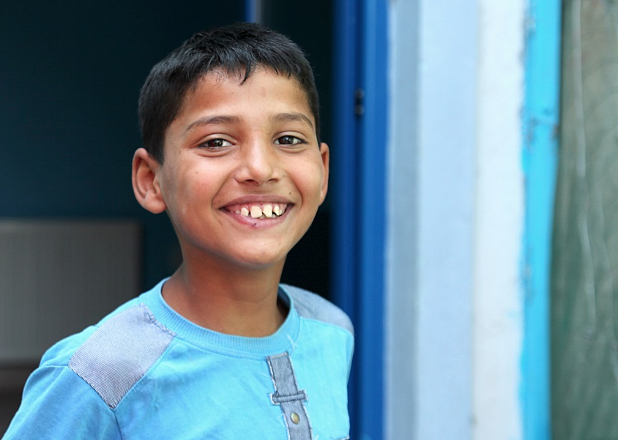 | Piloting a  Child Protection Index in Bosnia and Herzegovina
Selection of Child Protection Index Experts in BiH | Selection of Child Protection Index Experts in BiH

TOR FOR DATA COLLECTION EXPERTS

BACKGROUND
World Vision is a Christian humanitarian organization dedicated to working with children, families, and their communities worldwide to reach their full potential by tackling the causes of poverty and injustice. In 2011 World Vision Middle East and Eastern Europe has supported the creation of ChildPact, the Regional Coalition for Child Protection (www.childpact.org).

ChildPact is a coalition of coalitions. Its members are national networks of child-focused NGOs from 10 countries: Albania, Armenia, Azerbaijan, Bosnia and Herzegovina, Bulgaria, Kosovo, Georgia, the Republic of Moldova, Romania, and Serbia.

‘Stronger Voice for Children’ (SVC) is ChildPact’s member in BiH that was established to strengthen influence of civil society organizations on local, national and international level with the aim of promotion and implementation of UN Convention on the Rights of the Child and improvement of children quality of life in Bosnia and Herzegovina. Main activities of the Network include promotion of children participation, child rights monitoring in the country and advocacy.
ChildPact brings together more than 600 NGOs which serve more than 500,000 children. ChildPact’s first objective is to monitor and influence child-related policies by documenting child protection concerns and advocating for better policies to protect vulnerable children. With support from World Vision ChildPact is now piloting a Child Protection Index, to reflect on child protection systems in ChildPact’s member countries with a goal to develop a region-wide monitoring agenda on child protection reforms and implementation.

In the long term, this Index will facilitate innovative and necessary regional cooperation on child protection. Our objectives for this index include: 1. To provide an evidence-based approach to policy debates; 2. To identify needs and gaps in child protection systems; 3. To create cross-national comparisons for advocacy and funding purposes; 4. To push for new efforts on data population; 5. To unify various sectors and actors (government, civil society and academia) under shared principles and increase collaboration; and 6. To offer incentives and answers for qualitative and quantitative growth in child protection systems.

With funding from the German Federal Ministry for Economic Cooperation and Development, World Vision Middle East and Eastern Europe, ChildPact, World Vision and ‘Stronger Voice for Children’ are now developing the Child Protection Index in BiH, after having piloted in Romania, Bulgaria, Moldova, Georgia and Serbia.

To this aim 1 legal expert is sought.

QUALIFICATIONS

The legal expert should meet the following conditions:
- Hold university degree in legal studies
- Have relevant child protection expertise
- Have an excellent command of English (reading, writing, speaking)

SCOPE OF WORK
The selected experts are required to participate to a 1-day training on the data collection methodology and provide documented answers to approximately 250 indicators, within an agreed timeframe of approximately two months. The training will take place in September/October 2015, while the data collection will be conducted in October and November 2015.

HOW TO APPLY
If interested please send your CV and a motivation letter in English to Berina Ceribašić, berinasvc@gmail.com , before September 13th.

This designation is without prejudice to positions on status, and is in line with UNSCR 1244 and the ICJ Opinion on the Kosovo declaration of independence.
More information about ChildPact and its objectives is available at: http://www.childpact.org/about-us/what-we-do/.
For a quick overview of the Child Protection Index intent please see the animation available at: http://www.childpact.org/child-protection-index.
The preliminary results from Georgia are available here: http://www.childpact.org/2015/06/08/measuring-georgias-child-protection-reforms.

